**Name:** Aditya Somani **Roll No:** BE1851061 **PRN:** 71901204L

**Assignment No 3**

**Aim:** Create Association Rules for the Market Basket Analysis for the given Threshold.

(Using R)

**Association Rules**

There are many ways to see the similarities between items. These are techniques that fall under the general umbrella of association. The outcome of this type of technique, in simple terms, is a set of rules that can be understood as “if this, then **that”**.

**Applications**

There are many applications of association:

* Product recommendation – like Amazon’s “customers who bought that, also bought this”
* Music recommendations – like Last FM’s artist recommendations
* Medical diagnosis – like with diabetes really cool stuff
* Content optimisation – like in magazine websites or blogs

In this post we will focus on the retail application – it is simple, intuitive, and the dataset comes packaged with R making it repeatable.

**The Groceries Dataset**

Imagine 10000 receipts sitting on your table. Each receipt represents a transaction with items that were purchased. The receipt is a representation of stuff that went into a customer’s basket – and therefore ‘Market Basket Analysis’.

That is exactly what the Groceries Data Set contains:

a collection of receipts with each line representing 1 receipt and the items purchased. Each line is called a transaction and each column in a row represents an item.You can download the Groceries data set to take a look at it, but this is not a necessary step.

**Background:**

We can represent our items as an item set as follows:

I = { i1, i2, i3 .. in }

Therefore a transaction is represented as follows:

tn = { ij, ik,…..in}

This gives us our rules which are represented as follows:

{i1, i2} => ik

which can be read as “**if a user buys an item in the item set on the left hand side, then the user will likely buy the item on the right hand side too”.**

A more human readable example is:

{Coffee, Sugar} => milk

If a customer buys coffee and sugar, then they are also likely to buy milk.

With this we can understand three important ratios; the support, confidence and lift. We describe the significance of these in the following bullet points.

* Support: The fraction of which our item set occurs in our dataset.
* Confidence: probability that a rule is correct for a new transaction with items on

the left.

* Lift: The ratio by which by the confidence of a rule exceeds the expected

confidence.

Note: if the lift is 1 it indicates that the items on the left and right are Independent

**Apriori Recommendation with R**

So lets get started by loading up our libraries and data set.

*# Load the libraries*

library(arules)

library(arulesViz)

library(datasets)

*# Load the data set*

data(Groceries)

Lets explore the data before we make any rules:

*# Create an item frequency plot for the top 20 items*

itemFrequencyPlot(Groceries,topN=20,type="absolute")

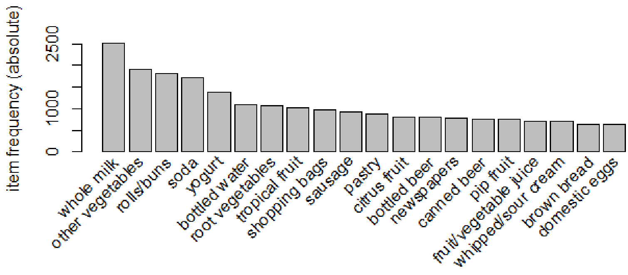

We are now ready to mine some rules!

You will always have to pass the minimum required support and confidence.

* We set the minimum support to 0.001
* We set the minimum confidence of 0.8
* We then show the top 5 rules

*# Get the rules*

rules <- apriori(Groceries, parameter = list(supp = 0.001, conf = 0.8))

*# Show the top 5 rules, but only 2 digits*

options(digits=2)

inspect(rules[1:5])

The output we see should look something like this

lhs rhs support confidence lift

1 {liquor,red/blush wine} => {bottled beer} 0.0019 0.90 11.2

2 {curd,cereals} => {whole milk} 0.0010 0.91 3.6

3 {yogurt,cereals} => {whole milk} 0.0017 0.81 3.2

4 {butter,jam} => {whole milk} 0.0010 0.83 3.3

5 {soups,bottled beer} => {whole milk} 0.0011 0.92 3.6

This reads easily, for example: if someone buys yogurt and cereals, they are 81% likely to buy whole milk too.

We can get summary info. about the rules that give us some interesting information such as:

* The number of rules generated: 410
* The distribution of rules by length: Most rules are 4 items long
* The summary of quality measures: interesting to see ranges of support, lift, and confidence.
* The information on the data mined: total data mined, and minimum parameters

set of 410 rules

rule length distribution (lhs + rhs): sizes

3 4 5 6

29 229 140 12

summary of quality measures:

support conf. lift

Min. :0.00102 Min. :0.80 Min. : 3.1

1st Qu.:0.00102 1st Qu.:0.83 1st Qu.: 3.3

Median :0.00122 Median :0.85 Median : 3.6

Mean :0.00125 Mean :0.87 Mean : 4.0

3rd Qu.:0.00132 3rd Qu.:0.91 3rd Qu.: 4.3

Max. :0.00315 Max. :1.00 Max. :11.2

mining info:

data n support confidence

Groceries 9835 0.001 0.8

**Sorting stuff out**

The first issue we see here is that the rules are not sorted. Often we will want the most relevant rules first.Lets say we wanted to have the most likely rules. We can easily sort by confidence by executing the following code.

rules<-sort(rules, by="confidence", decreasing=TRUE)

Now our top 5 output will be sorted by confidence and therefore the most relevant rules appear.

lhs rhs support conf. lift

1 {rice,sugar} => {whole milk} 0.0012 1 3.9

2 {canned fish,hygiene articles} => {whole milk} 0.0011 1 3.9

3 {root vegetables,butter,rice} => {whole milk} 0.0010 1 3.9

4 {root vegetables,whipped/sour cream,flour} => {whole milk} 0.0017 1 3.9

5 {butter,soft cheese,domestic eggs} => {whole milk} 0.0010 1 3.9

Rule 4 is perhaps excessively long. Lets say you wanted more concise rules. That is also easy to do by adding a “maxlen” parameter to your apriori function

rules <- apriori(Groceries, parameter = list(supp = 0.001, conf =

0.8,maxlen=3))

**Redundancies**

Sometimes, rules will repeat. Redundancy indicates that one item might be a given. As an analyst you can elect to drop the item from the dataset. Alternatively, you can remove redundant rules generated. We can eliminate these repeated rules using the follow snippet of code:

subset.matrix <- is.subset(rules, rules)

subset.matrix[lower.tri(subset.matrix, diag=T)] <- NA

redundant <- colSums(subset.matrix, na.rm=T) >= 1

rules.pruned <- rules[!redundant]

rules<-rules.pruned

**Targeting Items**

Now that we know how to generate rules, limit the output, lets say we wanted to target items to generate

rules. There are two types of targets we might be interested in that are illustrated with an example of “whole milk”:

* What are customers likely to buy before buying whole milk
* What are customers likely to buy if they purchase whole milk?

This essentially means we want to set either the Left Hand Side and Right Hand Side. This is not difficult to do with R! Answering the first question we adjust our apriori() function as follows:

rules<-apriori(data=Groceries, parameter=list(supp=0.001,conf = 0.08),

appearance = list(default="lhs",rhs="whole milk"),

control = list(verbose=F))

rules<-sort(rules, decreasing=TRUE,by="confidence")

inspect(rules[1:5])

The output will look like this:

lhs rhs supp. conf. lift

1 {rice,sugar} => {whole milk} 0.0012 1 3.9

2 {canned fish,hygiene articles} => {whole milk} 0.0011 1 3.9

3 {root vegetables,butter,rice} => {whole milk} 0.0010 1 3.9

4 {root vegetables,whipped/sour cream,flour} => {whole milk} 0.0017 1 3.9

5 {butter,soft cheese, domestic eggs} => {whole milk} 0.0010 1 3.9

**Visualization**

The last step is visualization. Lets say you wanted to map out the rules in a graph. We can do that with another library called “arulesViz”.

library(arulesViz)

plot(rules,method="graph",interactive=TRUE,shading=NA)

You will get a nice graph that you can move around to look like this:

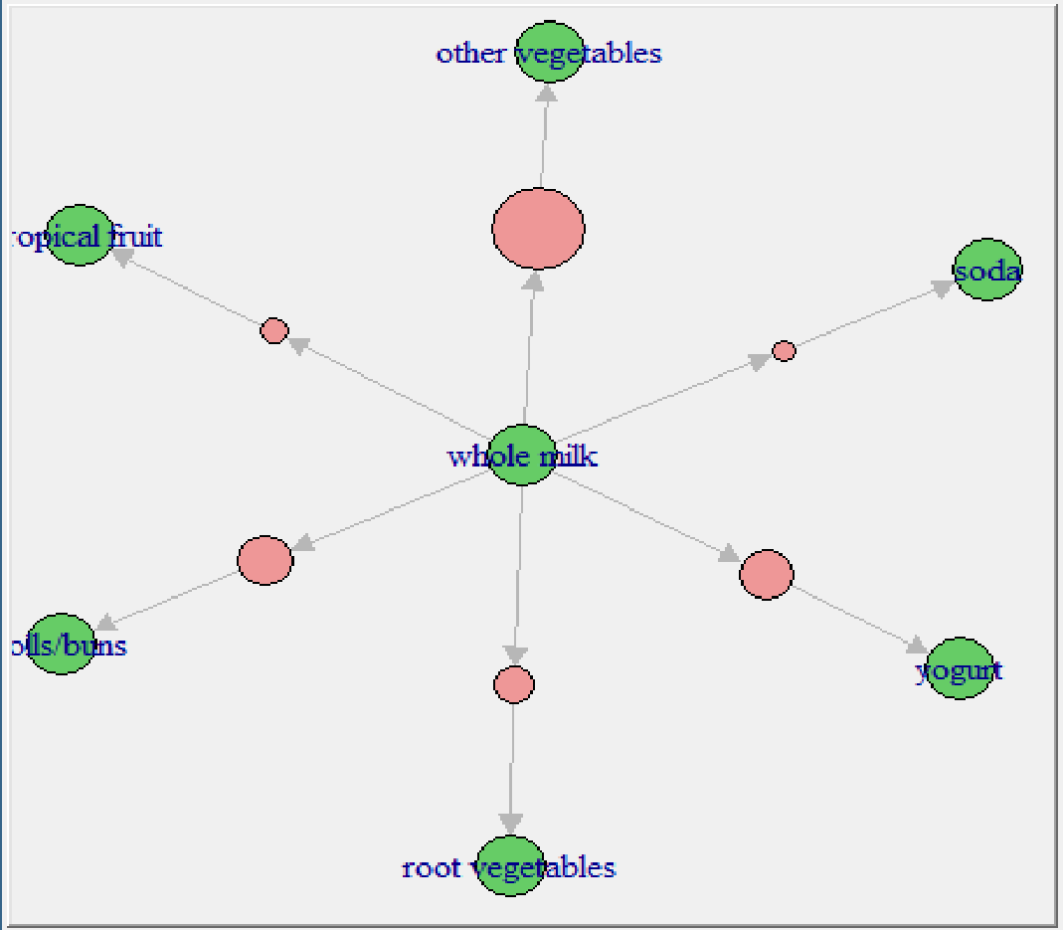

**Conclusion:**

Thus we have created Association Rule for the Market Basket Analysis for the given Threshold Using Rstudio

**# Load the libraries for apriori algorithm, visulizations and for required data set**

library(arules)

library(arulesViz)

library(datasets)

# Load the data set

data(Groceries)

#Lets explore the data before we make any rules:

# Create an item frequency plot for the top 20 items

itemFrequencyPlot(Groceries,topN=20,type="absolute")

#You will always have to pass the minimum required support and confidence.

# We set the minimum support to 0.001

# We set the minimum confidence of 0.8

# Get the rules

rules <- apriori(Groceries, parameter = list(supp = 0.001, conf = 0.8))

# Show the top 5 rules, but only 2 digits

options(digits=2)

inspect(rules[1:5])

#Sorting Rules by confidence

rules<-sort(rules, by="confidence", decreasing=TRUE)

rules <- apriori(Groceries, parameter = list(supp = 0.001, conf = 0.8,maxlen=3))

# Redundancies

subset.matrix <- is.subset(rules, rules)

subset.matrix[lower.tri(subset.matrix, diag=T)] <- NA

redundant <- colSums(subset.matrix, na.rm=T) >= 1

rules.pruned <- rules[!redundant]

rules<-rules.pruned

#Targeting items

rules<-apriori(data=Groceries, parameter=list(supp=0.001,conf = 0.08),

appearance = list(default="lhs",rhs="whole milk"),

control = list(verbose=F))

rules<-sort(rules, decreasing=TRUE,by="confidence")

inspect(rules[1:5])

rules<-apriori(data=Groceries, parameter=list(supp=0.001,conf = 0.15,minlen=2),

appearance = list(default="rhs",lhs="whole milk"),

control = list(verbose=F))

rules<-sort(rules, decreasing=TRUE,by="confidence")

inspect(rules[1:5])

#Visualization

library(arulesViz)

plot(rules,method="graph",interactive=TRUE,shading=NA)

**CODE:**

**> library(arules)**

**> library(arulesViz)**

**> library(datasets)**

**> data(Groceries)**

**> itemFrequencyPlot(Groceries, topN=20,type="absolute")**

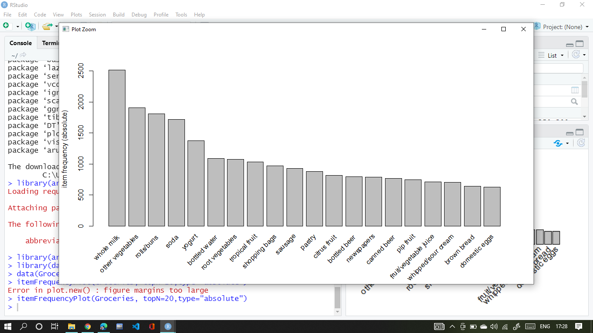

**> rules <- apriori(Groceries, parameter=list(supp=0.001,conf=0.8))**

Apriori

Parameter specification:

confidence minval smax arem aval originalSupport

0.8 0.1 1 none FALSE TRUE

maxtime support minlen maxlen target ext

5 0.001 1 10 rules TRUE

Algorithmic control:

filter tree heap memopt load sort verbose

0.1 TRUE TRUE FALSE TRUE 2 TRUE

Absolute minimum support count: 9

set item appearances ...[0 item(s)] done [0.00s].

set transactions ...[169 item(s), 9835 transaction(s)] done [0.01s].

sorting and recoding items ... [157 item(s)] done [0.00s].

creating transaction tree ... done [0.00s].

checking subsets of size 1 2 3 4 5 6 done [0.03s].

writing ... [410 rule(s)] done [0.00s].

creating S4 object ... done [0.00s].

**> options(digits=2)**

**> inspect(rules[1:5])**

lhs rhs support confidence coverage lift count

[1] {liquor,

red/blush wine} => {bottled beer} 0.0019 0.90 0.0021 11.2 19

[2] {curd,

cereals} => {whole milk} 0.0010 0.91 0.0011 3.6 10

[3] {yogurt,

cereals} => {whole milk} 0.0017 0.81 0.0021 3.2 17

[4] {butter,

jam} => {whole milk} 0.0010 0.83 0.0012 3.3 10

[5] {soups,

bottled beer} => {whole milk} 0.0011 0.92 0.0012 3.6 11

**> rules<-sort(rules,by="confidence",decreasing=TRUE)**

**> rules <- apriori(Groceries, parameter = list(supp=0.001, conf =0.8,maxlen=3))**

Apriori

Parameter specification:

confidence minval smax arem aval originalSupport

0.8 0.1 1 none FALSE TRUE

maxtime support minlen maxlen target ext

5 0.001 1 3 rules TRUE

Algorithmic control:

filter tree heap memopt load sort verbose

0.1 TRUE TRUE FALSE TRUE 2 TRUE

Absolute minimum support count: 9

set item appearances ...[0 item(s)] done [0.00s].

set transactions ...[169 item(s), 9835 transaction(s)] done [0.01s].

sorting and recoding items ... [157 item(s)] done [0.00s].

creating transaction tree ... done [0.01s].

checking subsets of size 1 2 3 done [0.01s].

writing ... [29 rule(s)] done [0.00s].

creating S4 object ... done [0.01s].

**> subset.matrix <- is.subset(rules,rules)**

**> subset.matrix[lower.tri(subset.matrix, diag=T)] <-NA**

**> redunbant <- colSums(subset.matrix, na.rm=T) >=1**

**> rules.pruned <- rules[!redunbant]**

**> rules<-rules.pruned**

**> rules <- apriori(data=Groceries, parameter=list(supp=0.001,conf=0.08), appearance = list(default="lhs", rhs="whole milk"), control = list(verbose=F))**

**> rules<-sort(rules, decreasing=TRUE,by="confidence")**

**> inspect(rules[1:5])**

lhs rhs support confidence coverage lift count

[1] {rice,

sugar} => {whole milk} 0.0012 1 0.0012 3.9 12

[2] {canned fish,

hygiene articles} => {whole milk} 0.0011 1 0.0011 3.9 11

[3] {root vegetables,

butter,

rice} => {whole milk} 0.0010 1 0.0010 3.9 10

[4] {root vegetables,

whipped/sour cream,

flour} => {whole milk} 0.0017 1 0.0017 3.9 17

[5] {butter,

soft cheese,

domestic eggs} => {whole milk} 0.0010 1 0.0010 3.9 10

**> rules<-apriori(data=Groceries,parameter=list(supp=0.001,conf=0.15,minlen=2), appearance = list(default="rhs",lhs="whole milk"), control = list(verbose=F))**

**> rules<-sort(rules,decreasing=TRUE,by="confidence")**

**> inspect(rules[1:5])**

lhs rhs support

[1] {whole milk} => {other vegetables} 0.075

[2] {whole milk} => {rolls/buns} 0.057

[3] {whole milk} => {yogurt} 0.056

[4] {whole milk} => {root vegetables} 0.049

[5] {whole milk} => {tropical fruit} 0.042

confidence coverage lift count

[1] 0.29 0.26 1.5 736

[2] 0.22 0.26 1.2 557

[3] 0.22 0.26 1.6 551

[4] 0.19 0.26 1.8 481

[5] 0.17 0.26 1.6 416

**> plot(rules,engine='interactive')**

